How Many Beetles Do We Need?

As a general rule of thumb, for sites densely populated with purple loosestrife the Wetland Restoration Program (WRP) recommends releasing the following quantities of beetles:
An acre, which is a common measurement of land area, is equal to 43,560 square feet.
That is 208.7 feet by 208.7 square feet. or 63.61 square meters.

Size of purple loosestrife infestation | Number of beetles to release*
<.5 acres | 2000-5000
>.5-1 acre | 5000-10,000
over 1 acre | 5000-10,000 beetles per acre
*dependent on your budget
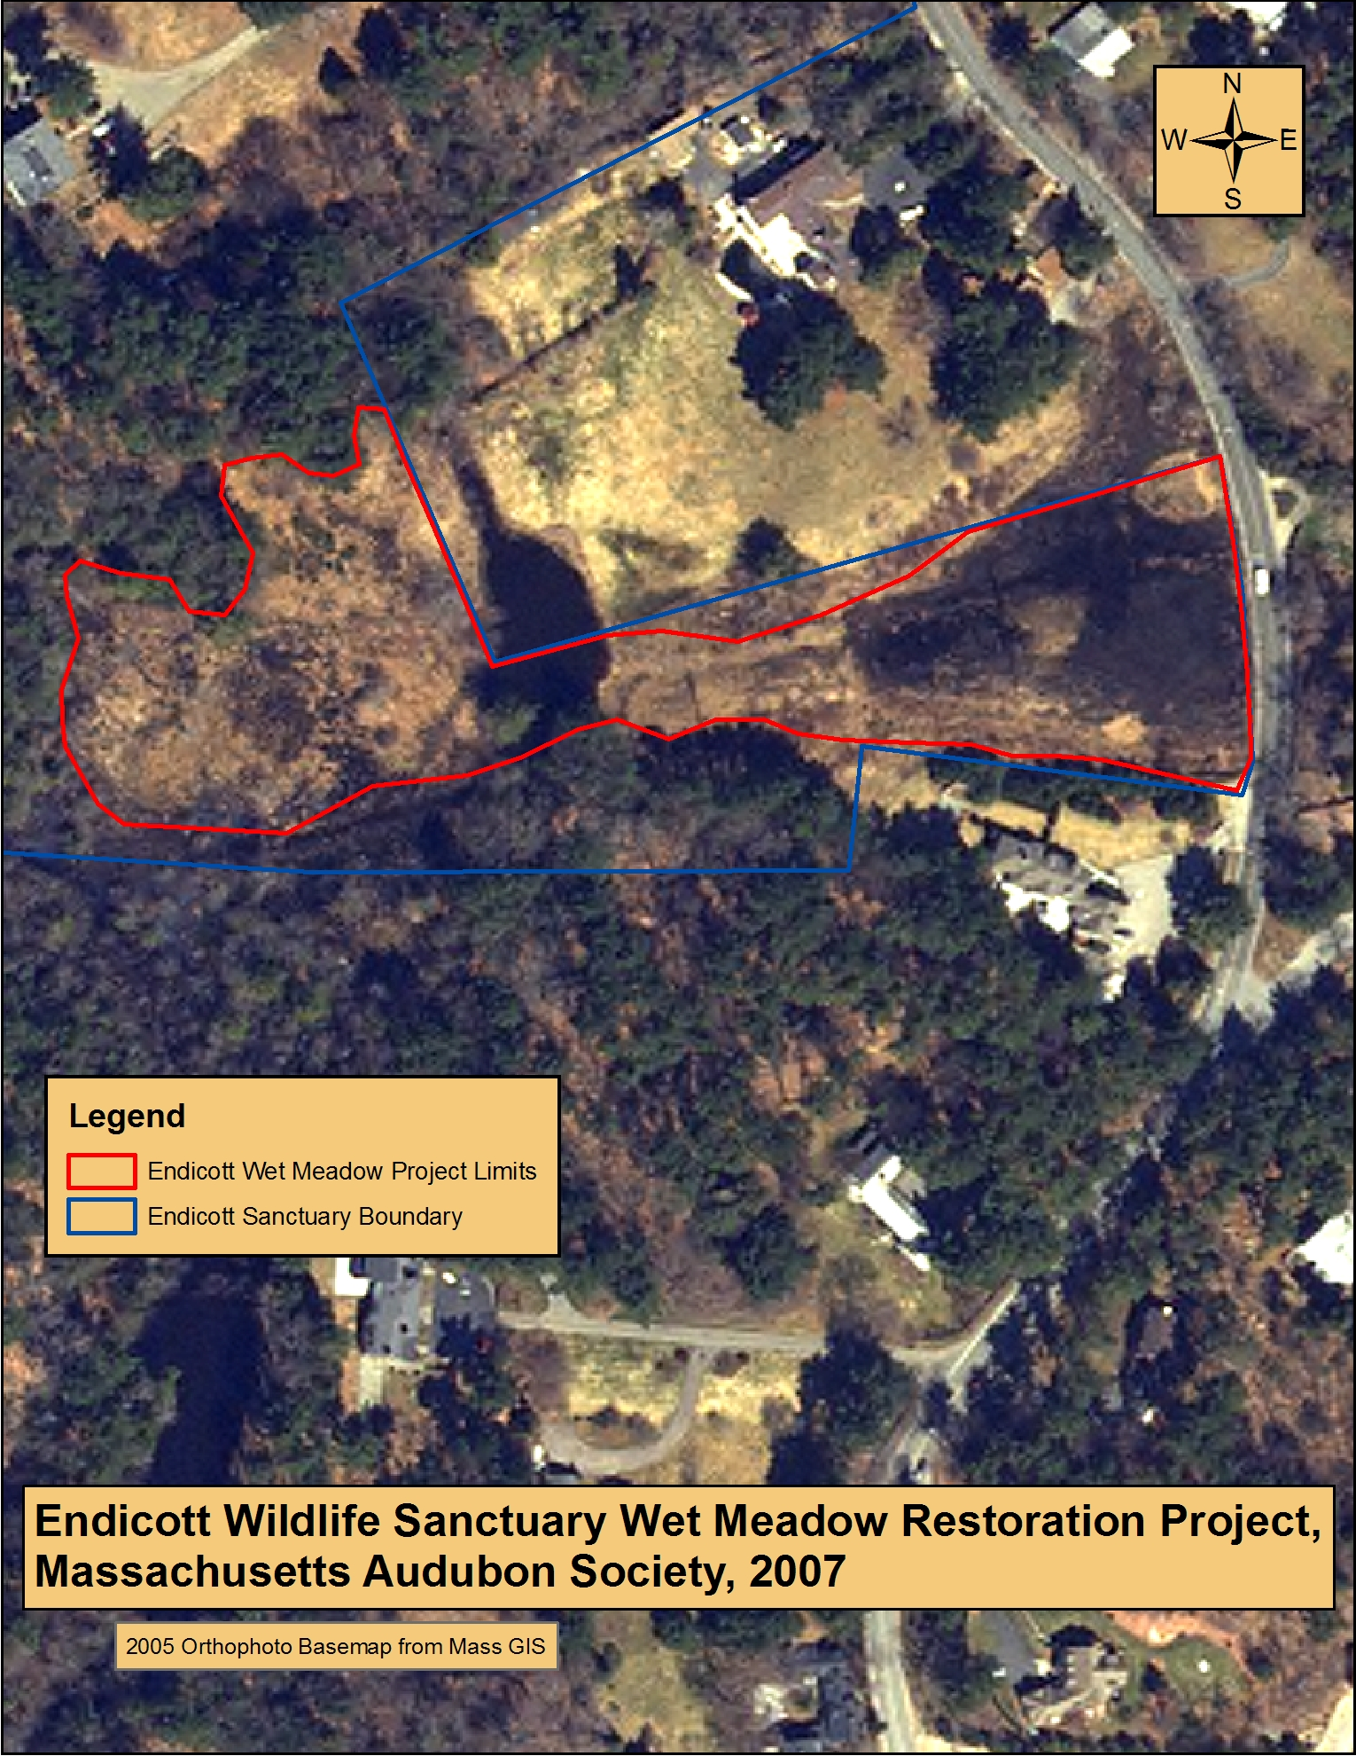

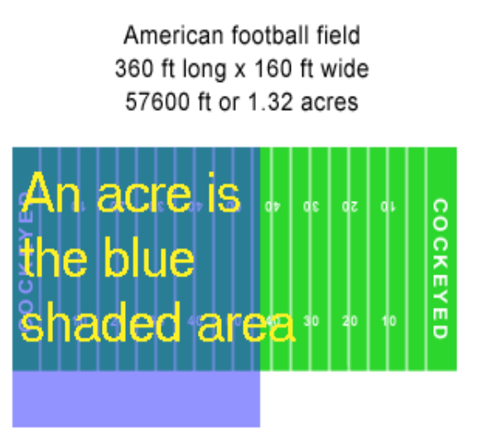

208.7 ft.

The wetland (in red) is approximately 3.5 acres. The majority of the site is infested with purple loosestrife.
Other key pieces of information:
Female beetles lay 10 eggs per day for 3-5 weeks.
Studies have shown that placing 10-15 beetles on each potted plant you raise is optimal.
12-14 pots fit into each wading pool.

Beetle Math:
1. Based on the WRP recommendations, how many beetles should be released on the site above?

2. If your school decided to raise beetles for Mass Audubon to help them control the purple loosestrife,
- how many adult beetles would need to be collected to put on pots to start your rearing project?
- How many pots would you need to raise?
- How many pools do you need ?

How many beetles do we need? Answers

Beetle Math:
Based on the WRP recommendations, how many beetles should be released on the site below?

17,500 to 35,000 beetles per year
Calculations:
10-15 adults (assume half (5-7.5) are female. Average is 6)

Each female lays eggs for 3-5 weeks. Four weeks is the average. Four weeks is 28 days.

Each female will produce 280 eggs. (28 days times ten per day)

6 females times 280= 1680 offspring per pot.

To produce at least 17,500 beetles, we would need to rear (17500/1680=) at least 10.4 pots. Round that up to 11 pots. To produce 35,000 beetles we would need to rear (35,000/1680=) at least 20.8 pots. Rounding that up to 21 pots.
1. That means we should collect (15*11)165 beetles (for an output of 17,500) and (15*21) 315 beetles (for an output of 35,000) to put on these pots.
For rearing the lower number we would be able to fit the pots in one pool, the higher number would require 2 pools
We might want to collect more beetles and raise more pots because we are new at this and there is a possibility not all will survive. At the same time, perhaps we don’t want to overdo it!

ANSWERS
For total output of 17,500 beetles:
- 165 adults
- 11 pots
- 1 pool.
For total output of 35,000 beetles:
- 315 adults
- 21 pots
- 2 pools.

Opitonal follow up: Look at a wetland near you that is infested with purple loosestrife. You can do this on Google Earth. Zoom in. Measure its perimeter and area using the measuring tool. You can double check this by bringing out a meter tape into the field, and measuring and calculating area. Estimate how big the infestation is. Estimate how many beetles would be needed for that site.
http://earth.google.com/

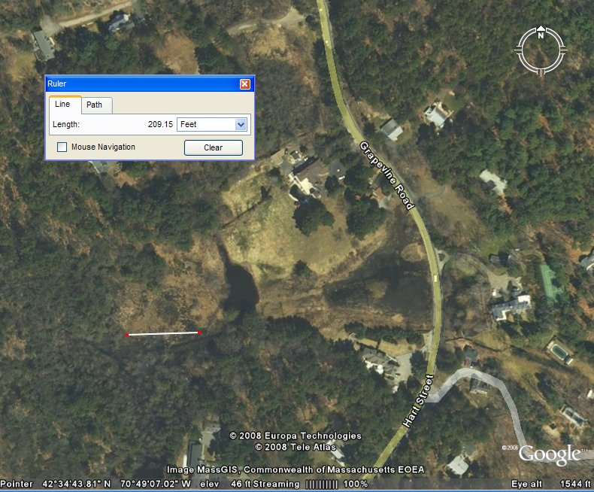

http://earth.google.com/

Here is an image from Google earth. The line represents one side of an acre if the acre is square.
Challenge students to come up with a way to measure the area of this wetland and then to find the area of a wetland near you using GoogleEarth.. You may want to work in small groups to calculate this.

